1. **Develop a website for a juice shop wherein the user is asked to choose from a list of fruits (use checkboxlist) and a list of ice creams (use radiobuttonlist) for the milkshake to be rendered. Provide a button that needs to display both the selections in a label along with price (random) for the milkshake. Use data binding with a list to populate the fruit and ice cream lists.**

**Code:**

**JuiceShop.aspx:**

<%@ Page Language="C#" AutoEventWireup="true" CodeBehind="JuiceShop.aspx.cs" Inherits="q1.JuiceShop" %>

<!DOCTYPE html>

<html xmlns="http://www.w3.org/1999/xhtml">

<head runat="server">

<title>Milkshakes</title>

</head>

<body>

<form id="form1" runat="server">

<div style="padding: 10px">

<h2>Fruits</h2>

<asp:CheckBoxList ID="CheckBoxList1" runat="server"></asp:CheckBoxList>

<br />

<br />

<h2>Icecreams</h2>

<asp:RadioButtonList ID="RadioButtonList1" runat="server"></asp:RadioButtonList>

<br />

<br />

<asp:Button ID="Button1" runat="server" Text="Order" Height="30px" OnClick="Button1_Click" Width="75px" />

<br />

<br />

<asp:Label ID="Label1" runat="server" Text=""></asp:Label>

</div>

</form>

</body>

</html>

**JuiceShop.aspx.cs:**

using System;

using System.Collections.Generic;

using System.Linq;

using System.Web;

using System.Web.UI;

using System.Web.UI.WebControls;

namespace q1

{

public partial class JuiceShop : System.Web.UI.Page

{

protected void Page_Load(object sender, EventArgs e)

{

if (!this.IsPostBack)

{

List<string> Fruits = new List<string>();

Fruits.Add("Mango");

Fruits.Add("Chickoo");

Fruits.Add("Apple");

Fruits.Add("Dragon Fruit");

List<string> Icecreams = new List<string>();

Icecreams.Add("Vanilla");

Icecreams.Add("Chocolate");

Icecreams.Add("Kitkat");

Icecreams.Add("Oreo");

CheckBoxList1.DataSource = Fruits;

RadioButtonList1.DataSource = Icecreams;

this.DataBind();

}

}

protected void Button1_Click(object sender, EventArgs e)

{

Label1.Text = "<h4>" + "You chose: " + "</h4>" + "<b>" + "Fruits: " + "</b>" + "<br/>";

foreach(ListItem itm in CheckBoxList1.Items)

{

if(itm.Selected == true)

{

Label1.Text += itm.Text + "<br/>";

}

}

Label1.Text += "<b>" + "<br/>" + "Icecreams: " + "</b>" + "<br/>" + RadioButtonList1.SelectedItem.Text + "<br/>";

Label1.Text += "<b>" + "<br/>" + "Price: " + "</b>";

Random r = new Random();

Label1.Text += r.Next(70, 140);

}

}

}

**Output:**

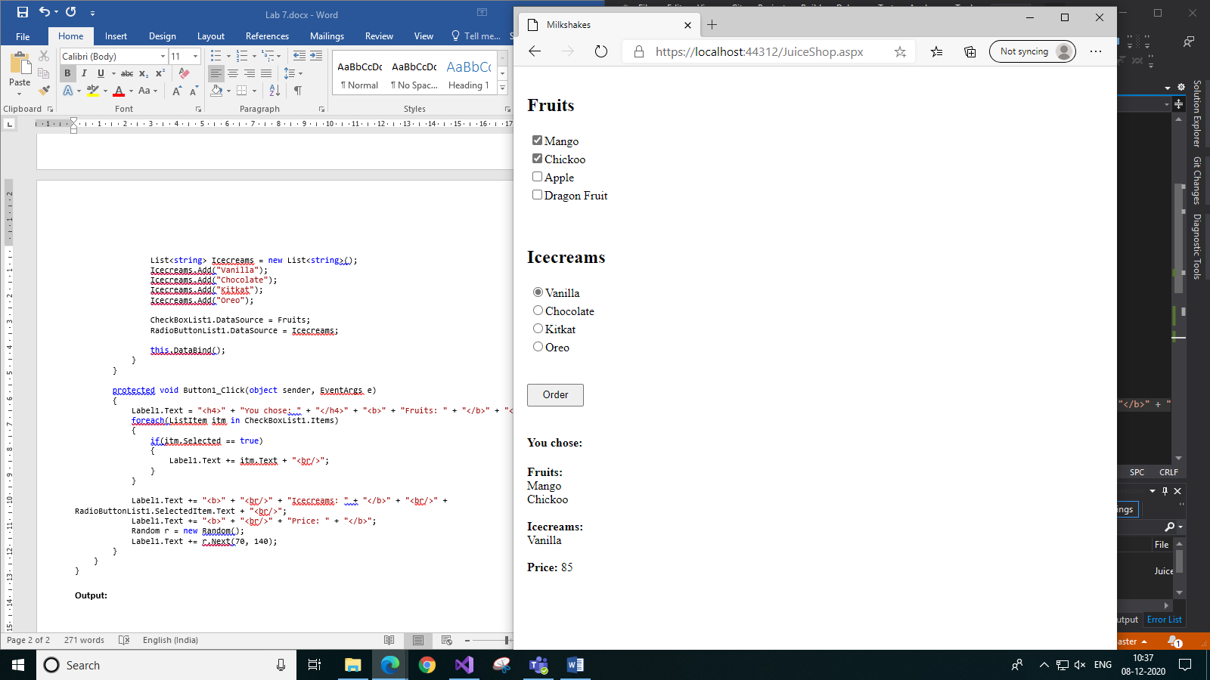

1. **Develop an ASP.NET website to display the names of the tour packages available with a travel agency in a Listbox using Sqldatasource in Page1. Use Sqldatasource and GridView control to display the entire detail of the package in Page2 based on the selection made in Page1 (the selected value in Page1 has to be sent to Page2 via querystring and in Page2 use Querystring parameter in sqldatasource control). Sample table data given below.**

**Packs Table schema and data:**

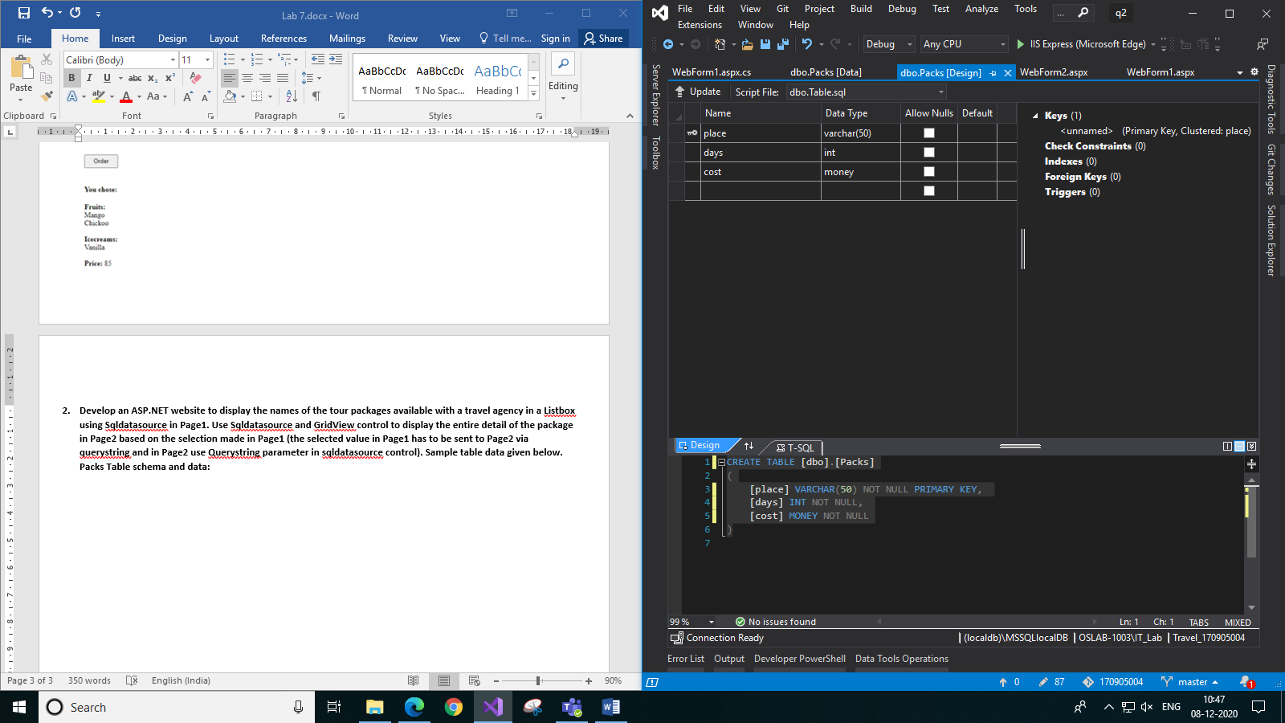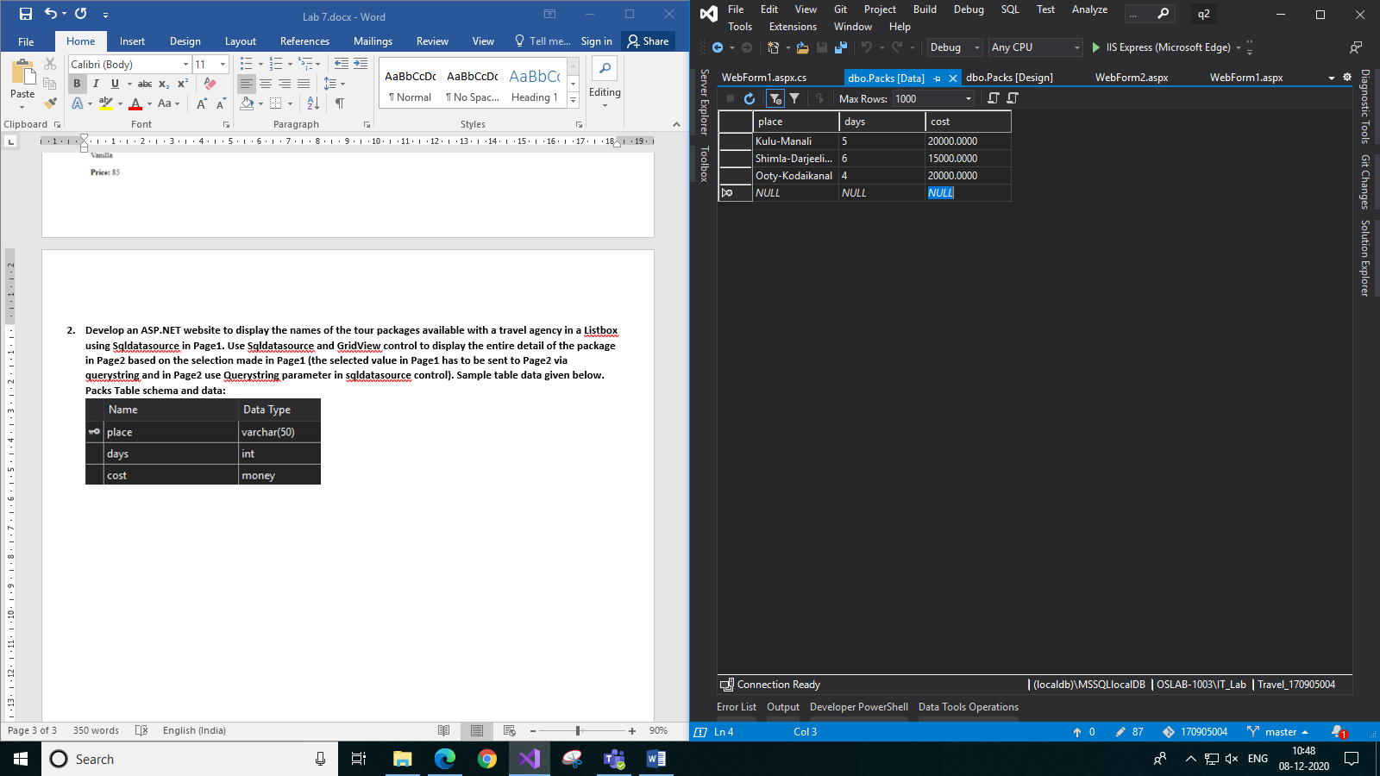

**Code:**

**WebForm1.aspx:**

<%@ Page Language="C#" AutoEventWireup="true" CodeBehind="WebForm1.aspx.cs" Inherits="q2.WebForm1" %>

<!DOCTYPE html>

<html xmlns="http://www.w3.org/1999/xhtml">

<head runat="server">

<title>Travel Packs</title>

</head>

<body>

<form id="form1" runat="server">

<div style="text-align:center">

<asp:SqlDataSource ID="SqlDataSource1" runat="server" ConnectionString="<%$ ConnectionStrings:Travel_170905004ConnectionString %>" SelectCommand="SELECT place FROM Packs"></asp:SqlDataSource>

<h3>Choose a travel pack:</h3>

<asp:ListBox ID="ListBox1" runat="server" DataSourceID="SqlDataSource1" DataTextField="place" Height="118px" Width="147px"></asp:ListBox>

<br />

<br />

<asp:Button ID="Button1" runat="server" Text="Check Details" Height="30px" Width="120px" OnClick="Button1_Click" />

</div>

</form>

</body>

</html>

**WebForm1.aspx.cs:**

using System;

using System.Collections.Generic;

using System.Linq;

using System.Web;

using System.Web.UI;

using System.Web.UI.WebControls;

namespace q2

{

public partial class WebForm1 : System.Web.UI.Page

{

protected void Page_Load(object sender, EventArgs e)

{

}

protected void Button1_Click(object sender, EventArgs e)

{

string url = "WebForm2.aspx?place=" + ListBox1.SelectedItem.Text;

Response.Redirect(url);

}

}

}

**WebForm2.aspx:**

<%@ Page Language="C#" AutoEventWireup="true" CodeBehind="WebForm2.aspx.cs" Inherits="q2.WebForm2" %>

<!DOCTYPE html>

<html xmlns="http://www.w3.org/1999/xhtml">

<head runat="server">

<title>Detailed Info</title>

</head>

<body>

<form id="form1" runat="server">

<div>

<asp:SqlDataSource ID="SqlDataSource1" runat="server" ConnectionString="<%$ ConnectionStrings:Travel_170905004ConnectionString %>" SelectCommand="SELECT * from Packs where place=@place">

<SelectParameters>

<asp:QueryStringParameter Name="place" QueryStringField="place" />

</SelectParameters>

</asp:SqlDataSource>

<asp:GridView ID="GridView1" runat="server" BackColor="White" BorderColor="#CCCCCC" BorderStyle="None" BorderWidth="1px" CellPadding="4" DataSourceID="SqlDataSource1" ForeColor="Black" GridLines="Horizontal" AutoGenerateColumns="False" DataKeyNames="place" style="margin: auto" HorizontalAlign="Center">

<Columns>

<asp:BoundField DataField="place" HeaderText="place" ReadOnly="True" SortExpression="place" />

<asp:BoundField DataField="days" HeaderText="days" SortExpression="days" ItemStyle-HorizontalAlign="Center" />

<asp:BoundField DataField="cost" HeaderText="cost" SortExpression="cost" />

</Columns>

<FooterStyle BackColor="#CCCC99" ForeColor="Black" />

<HeaderStyle BackColor="#333333" Font-Bold="True" ForeColor="White" />

<PagerStyle BackColor="White" ForeColor="Black" HorizontalAlign="Right" />

<SelectedRowStyle BackColor="#CC3333" Font-Bold="True" ForeColor="White" />

<SortedAscendingCellStyle BackColor="#F7F7F7" />

<SortedAscendingHeaderStyle BackColor="#4B4B4B" />

<SortedDescendingCellStyle BackColor="#E5E5E5" />

<SortedDescendingHeaderStyle BackColor="#242121" />

</asp:GridView>

</div>

</form>

</body>

</html>

**Output:**

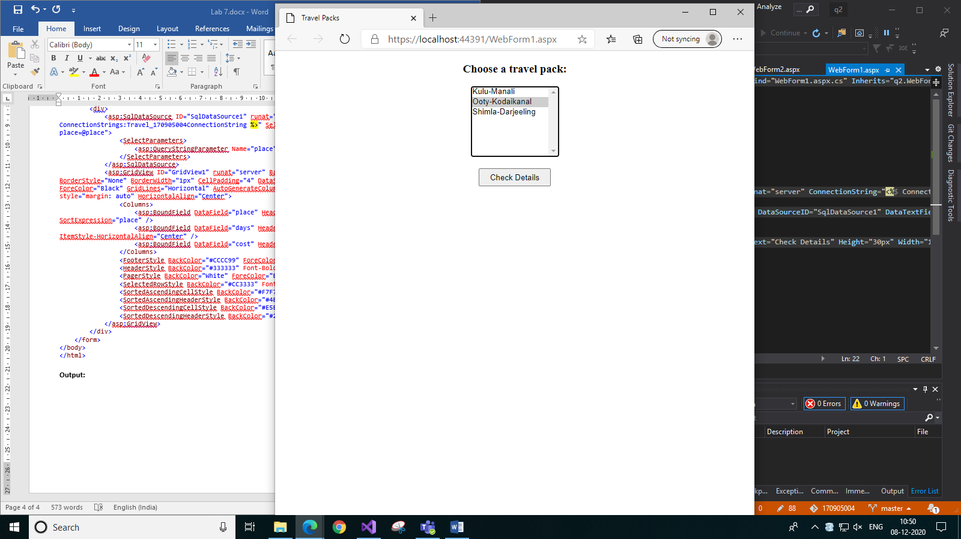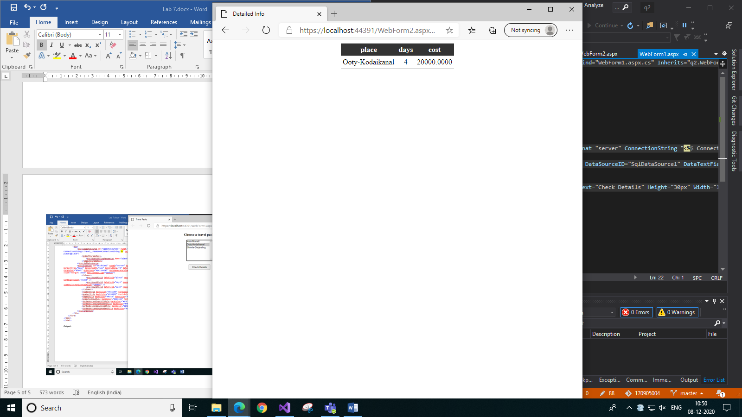

1. *Page1 b) Page2*
2. **Consider a table named City whose fields are as follows. 74 City: Id, StateID, CityName Develop a web application which allows a user to choose a State from the first DropDownList (bind it with a dictionary collection of at least five states during page load). Based on the value selected in the first DropDownList, the second DropDownList should be populated with the cities in that particular State fetched from the City table (use data source control). The keys of the dictionary can be mapped to the values of StateID in the table. The dictionary key has to be set as a DropDownList index, and the dictionary value has to be set as display value for the DropDownList.**

**City Table schema and data:**

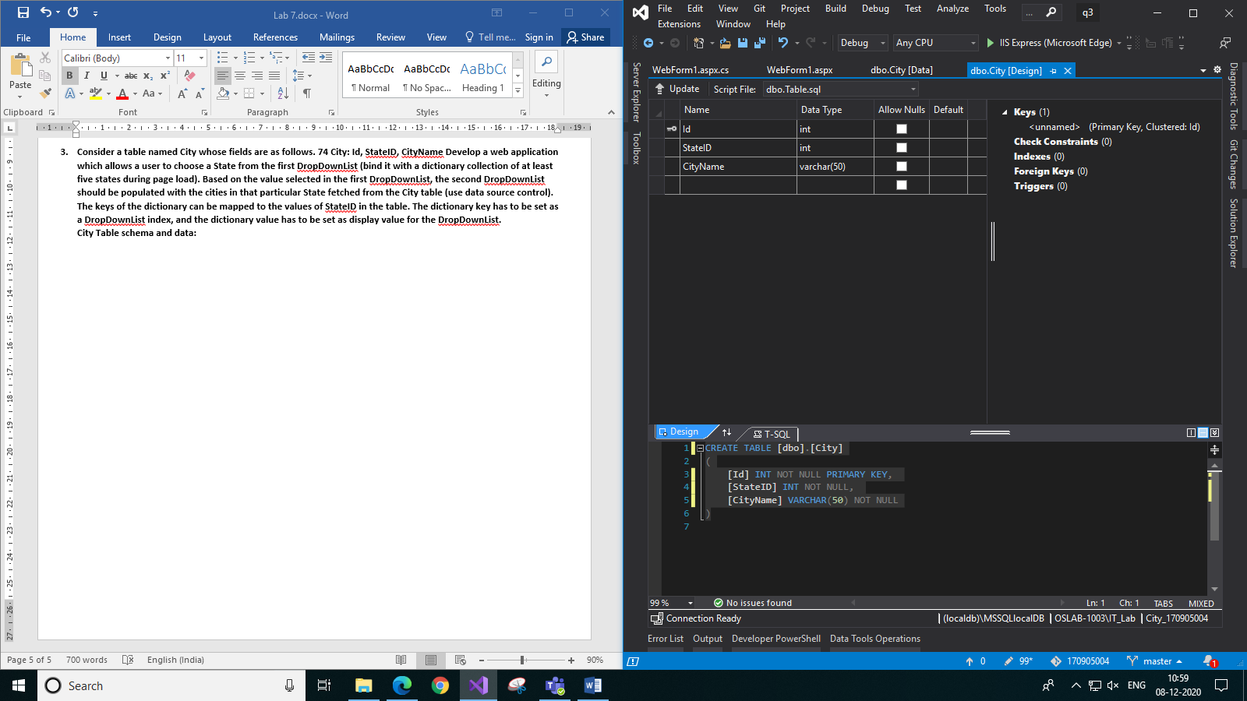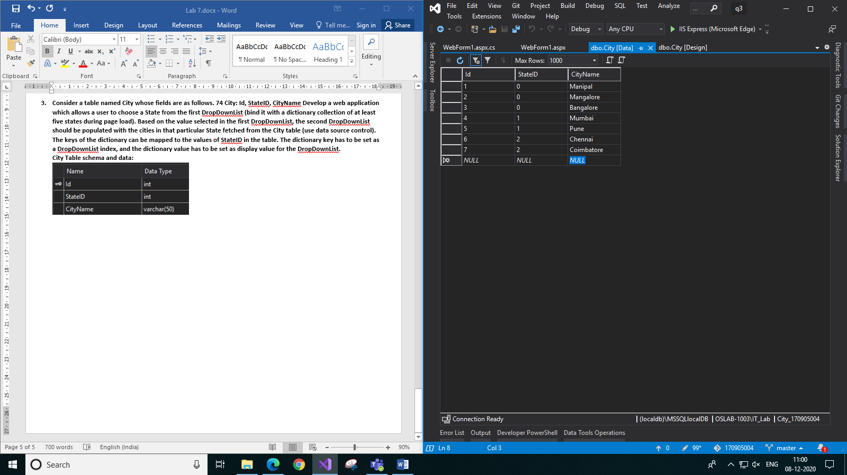

**Code:**

**WebForm1.aspx:**

<%@ Page Language="C#" AutoEventWireup="true" CodeBehind="WebForm1.aspx.cs" Inherits="q3.WebForm1" %>

<!DOCTYPE html>

<html xmlns="http://www.w3.org/1999/xhtml">

<head runat="server">

<title>City</title>

</head>

<body>

<form id="form1" runat="server">

<div>

Choose a state:

<asp:DropDownList ID="DropDownList1" runat="server" Height="30px" Width="145px" style="vertical-align:middle" AutoPostBack="True">

</asp:DropDownList>

<br />

<br />

<asp:SqlDataSource ID="SqlDataSource1" runat="server" ConnectionString="<%$ ConnectionStrings:City_170905004ConnectionString %>" SelectCommand="SELECT CityName from City WHERE StateID=@StateID">

<SelectParameters>

<asp:ControlParameter ControlID="DropDownList1" DefaultValue="0" Name="StateID" PropertyName="SelectedValue" />

</SelectParameters>

</asp:SqlDataSource>

Choose a city:

<asp:DropDownList ID="DropDownList2" runat="server" Height="30px" Width="145px" style="vertical-align:middle" AutoPostBack="True" DataSourceID="SqlDataSource1" DataTextField="CityName" OnSelectedIndexChanged="DropDownList2_SelectedIndexChanged">

</asp:DropDownList>

<br />

<br />

<asp:Label ID="Label1" runat="server" Text=""></asp:Label>

</div>

</form>

</body>

</html>

**WebForm1.aspx.cs:**

using System;

using System.Collections.Generic;

using System.Linq;

using System.Web;

using System.Web.UI;

using System.Web.UI.WebControls;

using System.Data;

using System.Data.Sql;

using System.Data.SqlClient;

namespace q3

{

public partial class WebForm1 : System.Web.UI.Page

{

protected void Page_Load(object sender, EventArgs e)

{

if (!this.IsPostBack)

{

Dictionary<int, string> states = new Dictionary<int, string>();

states.Add(0, "Karnataka");

states.Add(1, "Maharashtra");

states.Add(2, "Tamil Nadu");

DropDownList1.DataSource = states;

DropDownList1.DataTextField = "Value";

DropDownList1.DataValueField = "Key";

DropDownList1.DataBind();

}

}

protected void DropDownList2_SelectedIndexChanged(object sender, EventArgs e)

{

Label1.Text = "Welcome to " + DropDownList2.SelectedValue + ", " + DropDownList1.SelectedItem.Text;

}

}

}

**Output:**

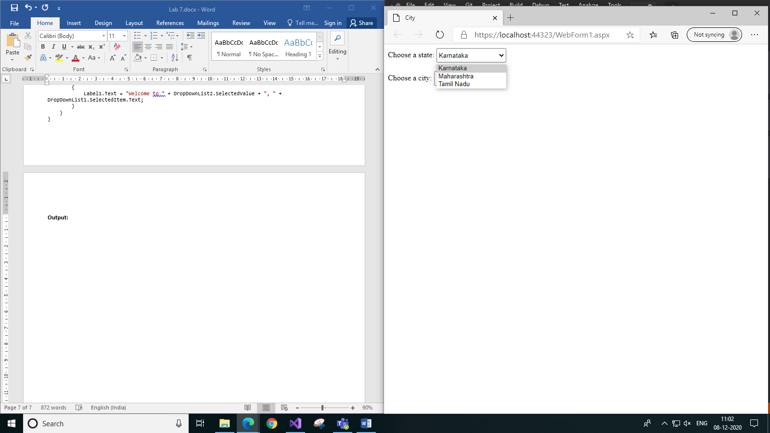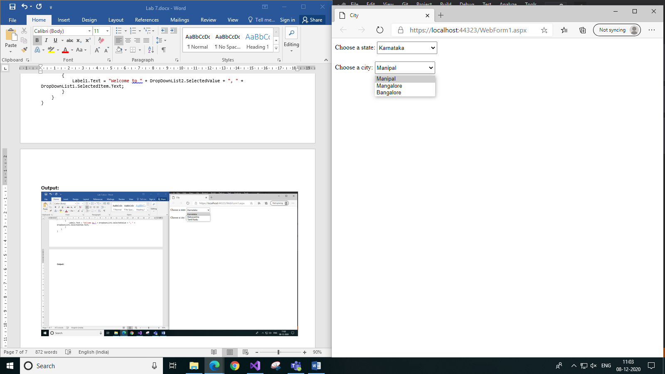

1. *Choosing in the first list b) Choosing in the second list*

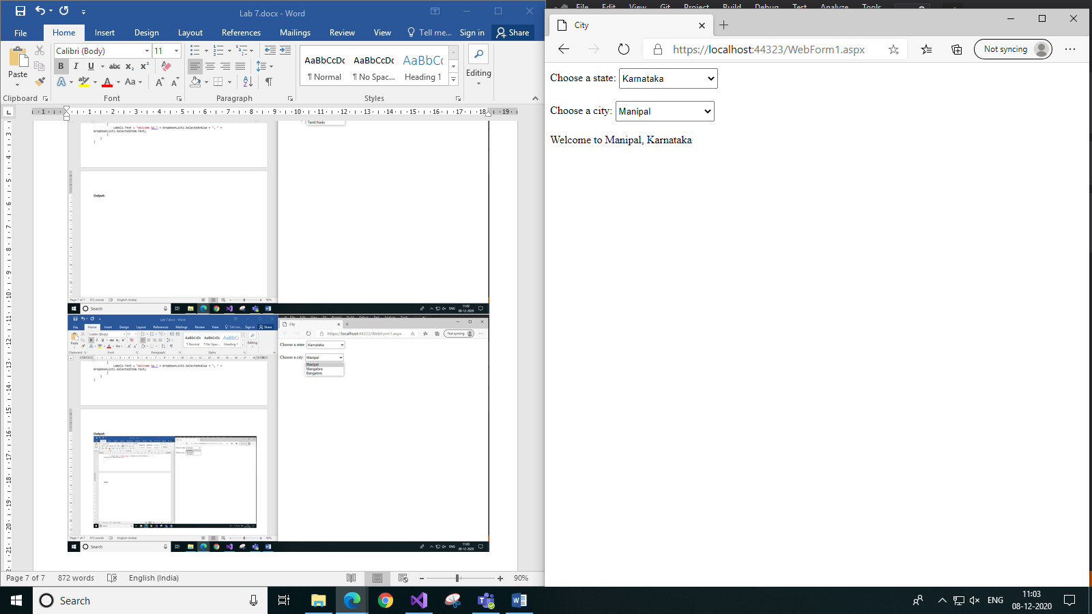 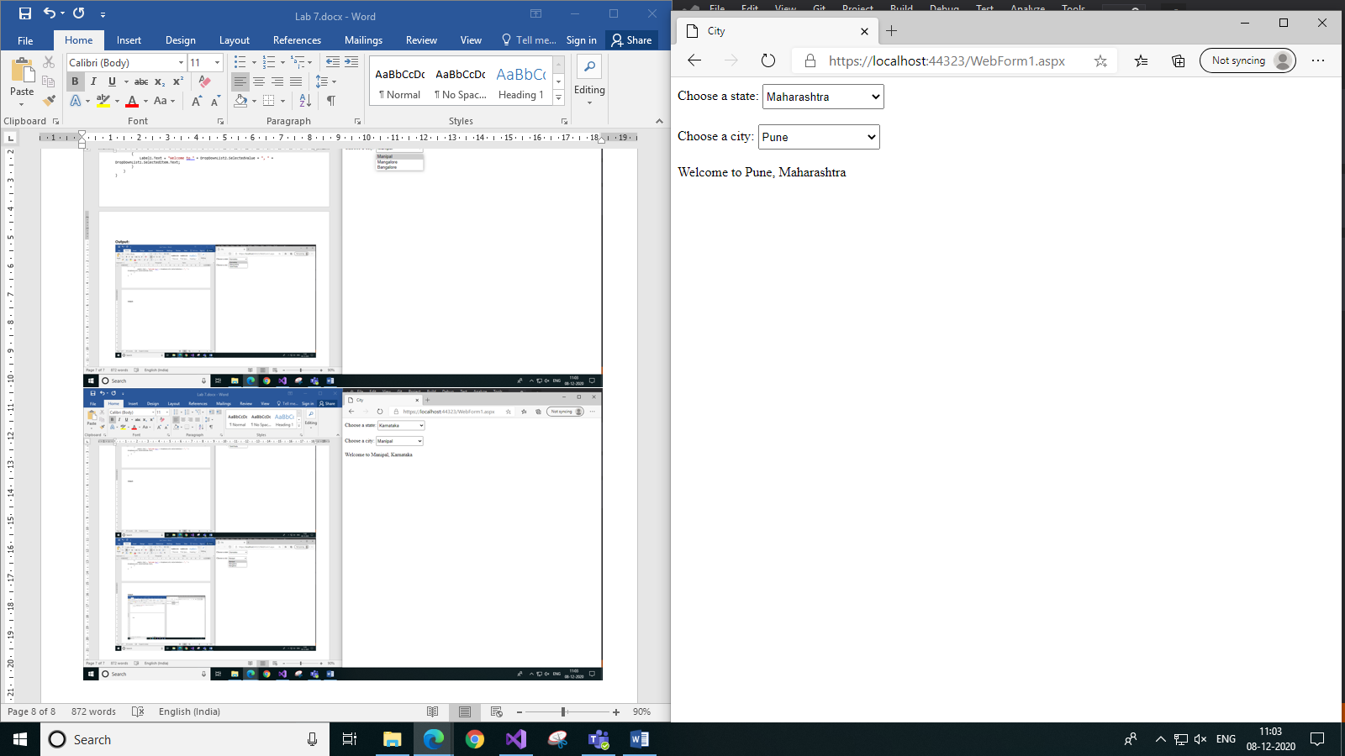

*c) After choosing both d) Choosing different option*

1. **Develop a web application that contains a DropDownList, a ListBox and a GridView. Use a list with values comedy, romance and animated (various categories) to bind with the DropDownList. The ListBox should display the names of the actors who belong to the category as that of the genre selected in the DropDownList. The GridView must display entire details of the actor based on the name selected in the ListBox. Use data source control for all database operations. The schema of the ‘Actors’ table is given below.(id can be set as a primary key)**

**Legends Table Schema and Data:**

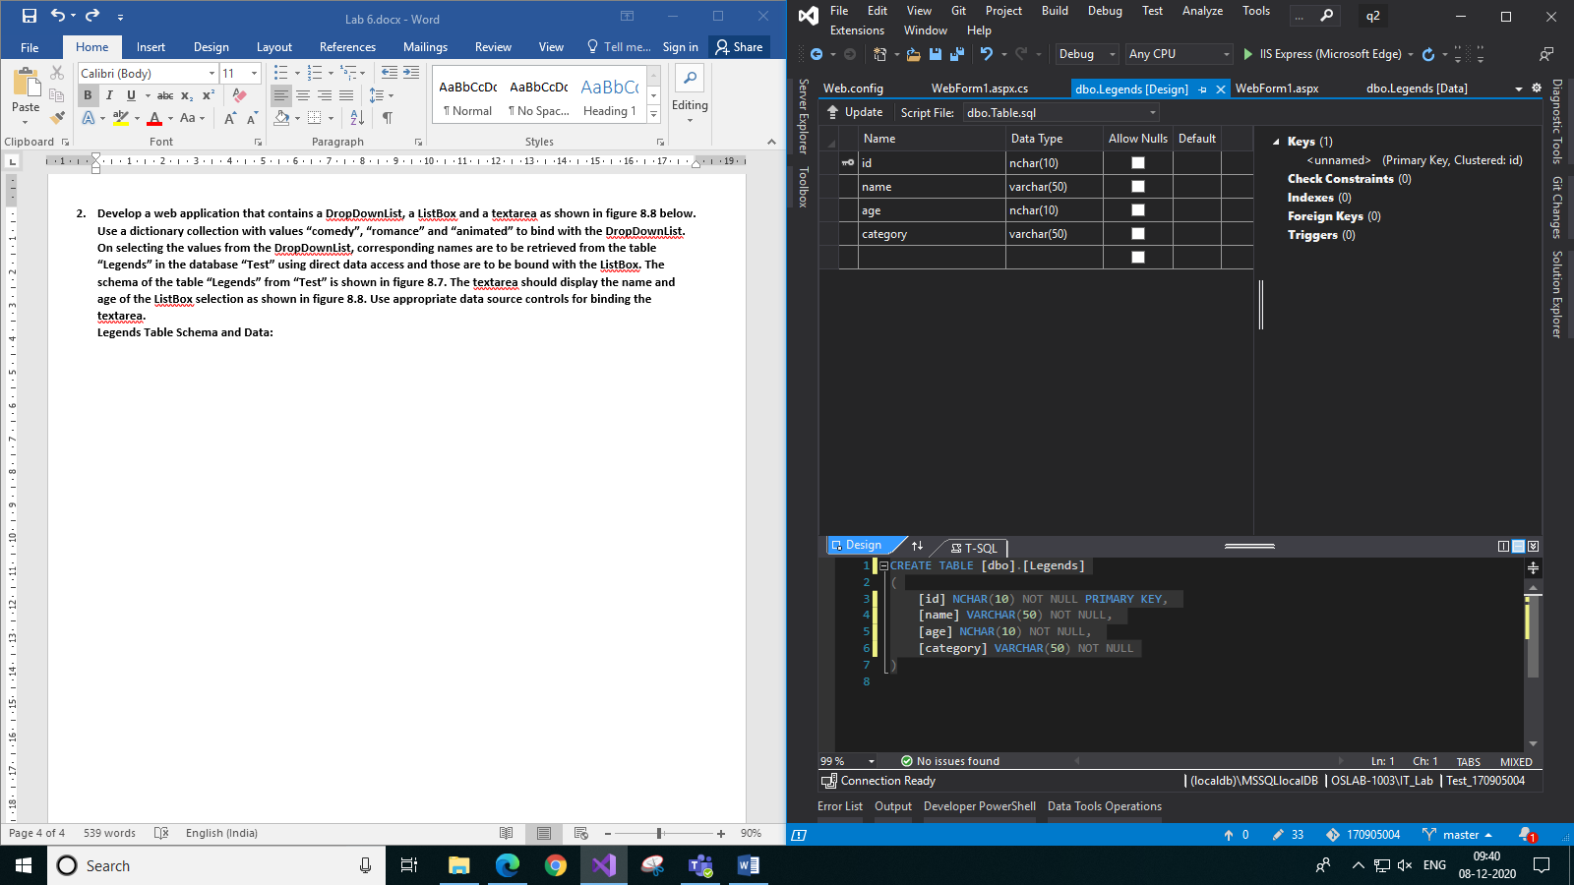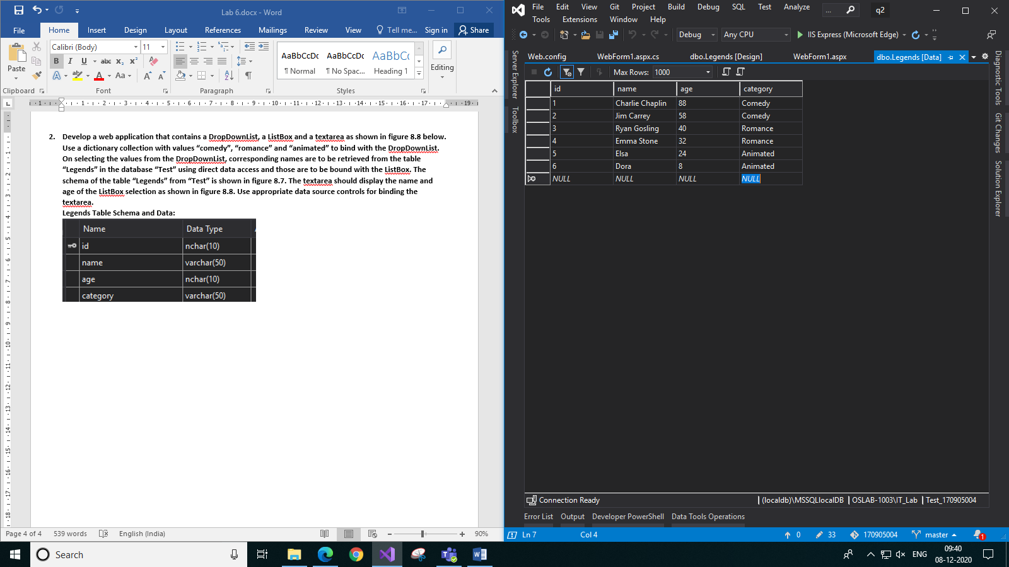

**Code:**

**WebForm1.aspx:**

<%@ Page Language="C#" AutoEventWireup="true" CodeBehind="WebForm1.aspx.cs" Inherits="q4.WebForm1" %>

<!DOCTYPE html>

<html xmlns="http://www.w3.org/1999/xhtml">

<head runat="server">

<title>Actors</title>

</head>

<body>

<form id="form1" runat="server">

<div style="text-align: center">

Choose category:

<asp:DropDownList ID="DropDownList1" runat="server" AutoPostBack="True" Height="30px" Width="100px" style="vertical-align:middle">

</asp:DropDownList>

<br />

<br />

Choose actor:<asp:SqlDataSource ID="SqlDataSource1" runat="server" ConnectionString="<%$ ConnectionStrings:Test_170905004ConnectionString %>" SelectCommand="SELECT id, name FROM Legends WHERE category=@category">

<SelectParameters>

<asp:ControlParameter ControlID="DropDownList1" DefaultValue="-" Name="category" PropertyName="SelectedItem.Text" />

</SelectParameters>

</asp:SqlDataSource>

<br />

<asp:ListBox ID="ListBox1" runat="server" DataSourceID="SqlDataSource1" DataTextField="name" DataValueField="id" AutoPostBack="True" Height="115px" Width="120px"></asp:ListBox>

<br />

<br />

<asp:SqlDataSource ID="SqlDataSource2" runat="server" ConnectionString="<%$ ConnectionStrings:Test_170905004ConnectionString %>" SelectCommand="SELECT * FROM Legends WHERE name=@name and id=@id">

<SelectParameters>

<asp:ControlParameter ControlID="ListBox1" Name="name" PropertyName="SelectedItem.Text" />

<asp:ControlParameter ControlID="ListBox1" Name="id" PropertyName="SelectedValue" />

</SelectParameters>

</asp:SqlDataSource>

<asp:GridView ID="GridView1" runat="server" CellPadding="4" ForeColor="#333333" GridLines="None" AutoGenerateColumns="False" DataKeyNames="id" DataSourceID="SqlDataSource2" style="margin: auto">

<AlternatingRowStyle BackColor="White" ForeColor="#284775" />

<Columns>

<asp:BoundField DataField="id" HeaderText="id" ReadOnly="True" SortExpression="id" />

<asp:BoundField DataField="name" HeaderText="name" SortExpression="name" />

<asp:BoundField DataField="age" HeaderText="age" SortExpression="age" />

<asp:BoundField DataField="category" HeaderText="category" SortExpression="category" />

</Columns>

<EditRowStyle BackColor="#999999" />

<FooterStyle BackColor="#5D7B9D" Font-Bold="True" ForeColor="White" />

<HeaderStyle BackColor="#5D7B9D" Font-Bold="True" ForeColor="White" />

<PagerStyle BackColor="#284775" ForeColor="White" HorizontalAlign="Center" />

<RowStyle BackColor="#F7F6F3" ForeColor="#333333" />

<SelectedRowStyle BackColor="#E2DED6" Font-Bold="True" ForeColor="#333333" />

<SortedAscendingCellStyle BackColor="#E9E7E2" />

<SortedAscendingHeaderStyle BackColor="#506C8C" />

<SortedDescendingCellStyle BackColor="#FFFDF8" />

<SortedDescendingHeaderStyle BackColor="#6F8DAE" />

</asp:GridView>

</div>

</form>

</body>

</html>

**WebForm1.aspx.cs:**

using System;

using System.Collections.Generic;

using System.Linq;

using System.Web;

using System.Web.UI;

using System.Web.UI.WebControls;

namespace q4

{

public partial class WebForm1 : System.Web.UI.Page

{

protected void Page_Load(object sender, EventArgs e)

{

if (!this.IsPostBack)

{

List<string> categories = new List<string>();

categories.Add("Comedy");

categories.Add("Romance");

categories.Add("Animated");

DropDownList1.DataSource = categories;

DropDownList1.DataBind();

}

}

}

}

**Output:**

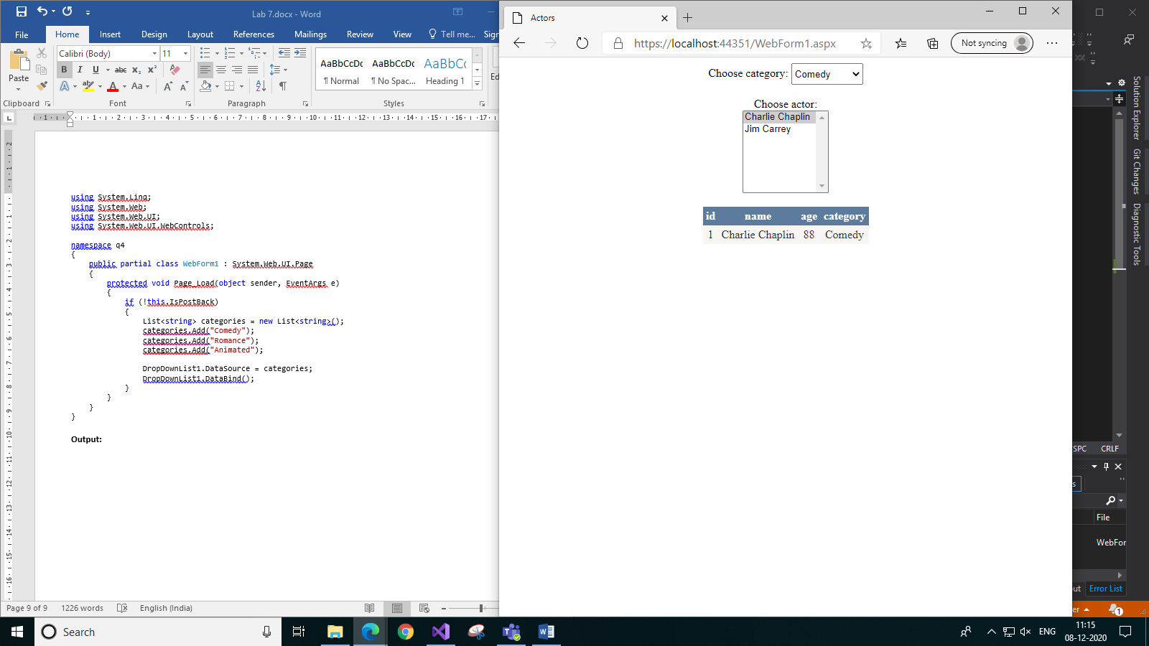 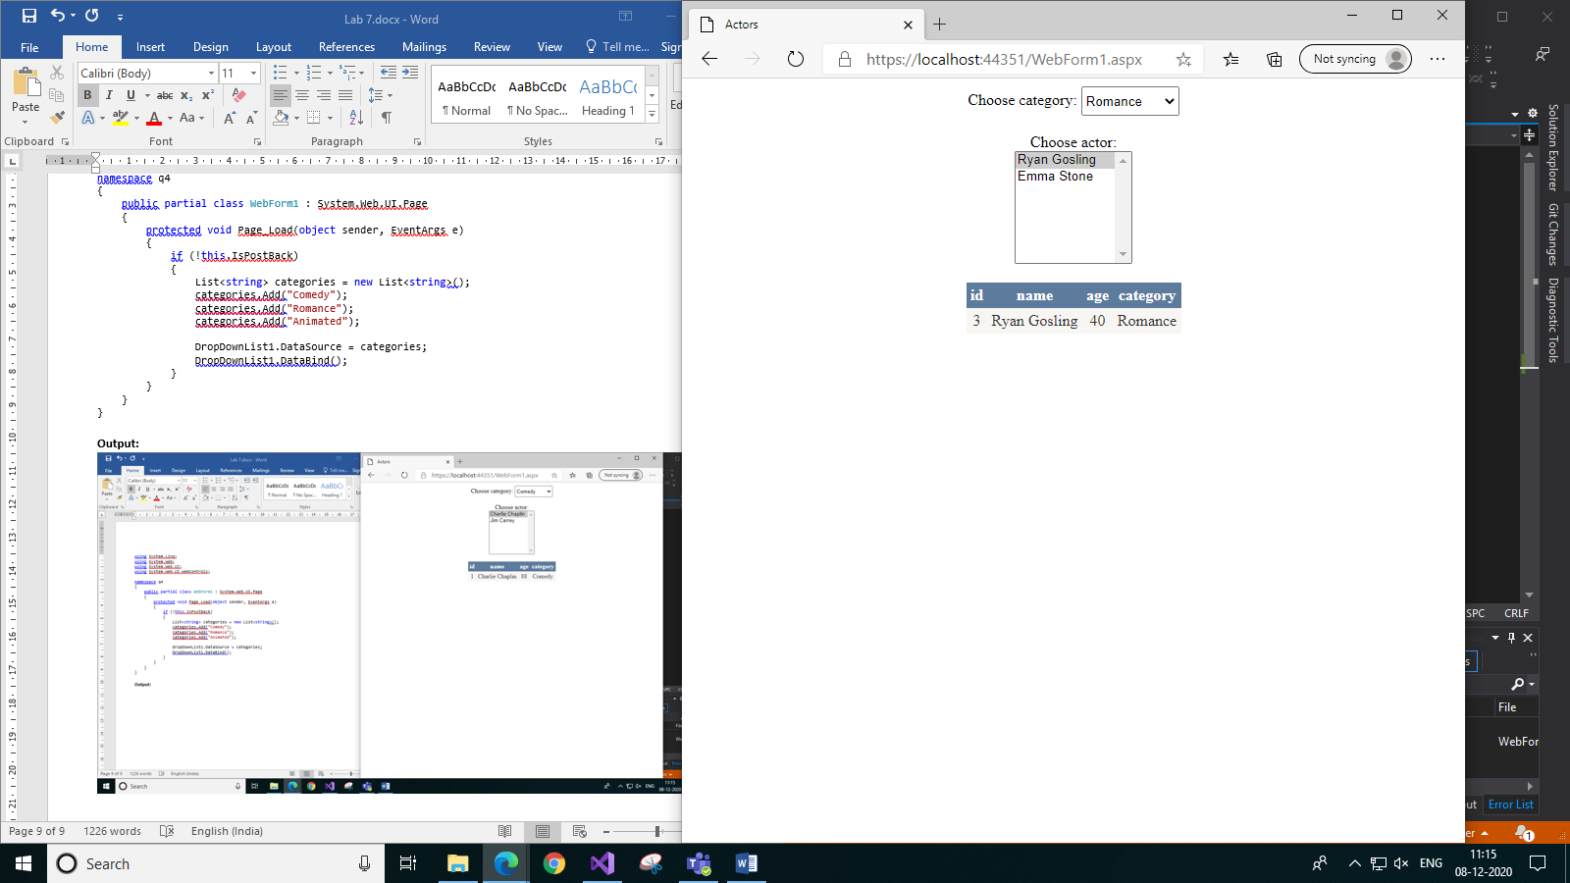

1. *Comedy category b) Romance category*